JOURNAL OF NEW LIBRARIANSHIP
Vol. xx, No. x, 2022
https://doi.org/xxxxxxxxxxxxxxxx
Peer-Reviewed Article

This is Where a Title Will Go
Author Name, Author Affiliation
Author Name, Author Affiliation
ABSTRACT
Your abstract should be no more than 150 words in length. This sample abstract text is 144 words. The abstract text will go here. This is sample abstract text that is copied over and over again. Your abstract should be no more than 150 words in length. This sample abstract text is 144 words. The abstract text will go here. This is sample abstract text that is copied over and over again. Your abstract should be no more than 150 words in length. This sample abstract text is 144 words. The abstract text will go here. This is sample abstract text that is copied over and over again. Your abstract should be no more than 150 words in length. This sample abstract text is 144 words. The abstract text will go here. This is sample abstract text that is copied over and over again.
KEYWORDS
Keyword 1, keyword 2, keyword 3
SUGGESTED CITATION
Last Name, 1st Initial. (Year). Title of manuscript in sentence case. Journal of New Librarianship, Vol #(Issue #), xx–xx. https://doi.org/xxxxxxxx

In this section, you can see what sample body text and sample headings look like and how they’re formatted. You can Sample Heading formats are listed below. You can copy and paste them as needed. Delete the sample headings before submitting your final column.

Heading Level 1
Text after Heading Level 1 begins as a new paragraph. This is sample body text. This is more sample body text. And more. This is sample body text. This is more sample body text. This is yet even more sample body text. And more. Text after Heading Level 1 begins as a new paragraph. This is sample body text. This is more sample body text. This is yet even more sample body text. And more.

Heading Level 2
Text after Heading Level 2 begins as a new paragraph. This is sample body text. This is more sample body text. This is yet even more sample body text. And more. This is sample body text. This is more sample body text. This is yet even more sample body text. And more. Text after Heading Level 2 begins as a new paragraph. This is sample body text. This is more sample body text. This is yet even more sample body text. And more.

Heading Level 3
Text after Heading Level 3 begins as a new paragraph. This is sample body text. This is more sample body text. This is yet even more sample body text. And more. This is sample body text. This is more sample body text. This is yet even more sample body text. And more. Text after Heading Level 3 begins as a new paragraph. This is sample body text. This is more sample body text. This is yet even more sample body text. And more.

Heading 4. Text after Heading Level 4 begins on the same line. This is sample body text. This is more sample body text. This is yet even more sample body text. And more. This is sample body text. This is more sample body text. This is yet even more sample body text. And more. Text after Heading Level 4 begins on the same line. This is sample body text. This is more sample body text. This is yet even more sample body text. And more.

Heading 5.
Text after Heading Level 5 begins on the same line. This is sample body text. This is more sample body text. This is yet even more sample body text. And more. This is sample body text. This is more sample body text. This is yet even more sample body text. And more. Text after Heading Level 5 begins on the same line. This is sample body text. This is more sample body text. This is yet even more sample body text. And more.

Table and Figure Formatting
In this section, you can see examples of tables and figures. Whenever including tables and figures, adhere to the formatting guidelines found in the APA 7 manual, or visit APA Style: Tables and Figures.
Table 1
Overall Patron Satisfaction with Self-Checkout
Feature | Very unsatisfied | Unsatisfied | Neutral | Satisfied | Very satisfied
Ease of use | 5 | 3 | 15 | 20 | 57
Wait time | 1 | 2 | 9 | 13 | 75
Intuitiveness | 4 | 4 | 12 | 35 | 45
Overall satisfaction | 3 | 3 | 12 | 24 | 58
Note. 100 patrons were surveyed.
Figure 1
Patron Satisfaction with Ease of Use of Self-Checkout
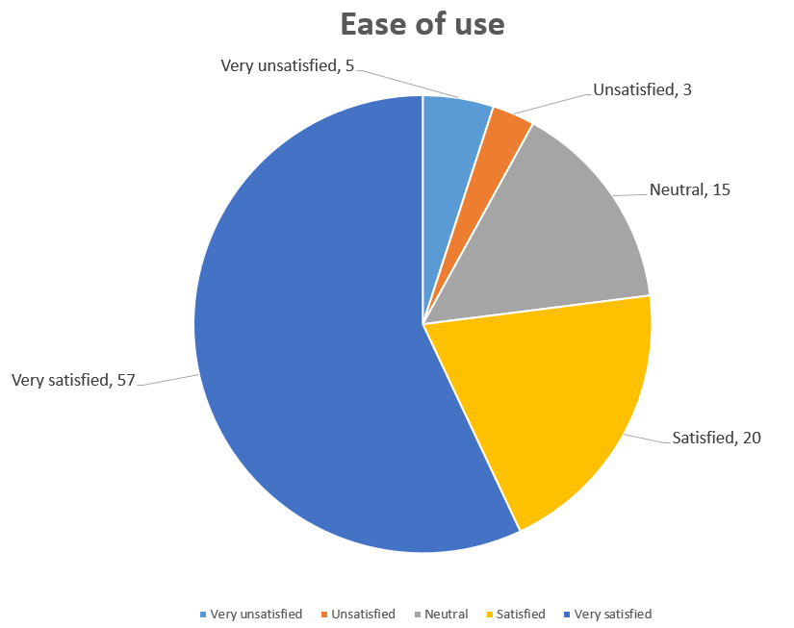
Note. 100 patrons were surveyed.

Block Quotations
Use block quotations for direct quotes that are made up of 40 words or more. Block quotations don’t use quotation marks, but rather they start on a new line and the whole block of text is indented by 0.5 in. If the quotation contains additional paragraphs, indent the first line of each extra paragraph an additional 0.5 in. For more information about formatting and citing block quotations, view the APA 7 manual or visit APA Style: Quotations. The example below showcases APA 7 block quote formatting:
In order to accurately estimate whether people are likely to form positive or negative expectations on any given occasion, it is necessary to go beyond simply considering chronic individual differences and identify the factors that make people more likely to form expectations in line with one bias or the other.
The present research sheds light on this issue by identifying a crucial distinction in the operation of these two train biases in expectation formation. Specifically, people’s valence weighting biases and self-beliefs about the future appear to shape expectations via qualitatively distinct processes. (Niese et al., 2019, p. 210)

References
Test, M. (2013). All references should use APA 7 citation style. The Journal of Sample References, 6(2). 133-158. https://doi.org/testdoi1234

Tables
Table 1
Overall Patron Satisfaction with Self-Checkout
Feature | Very unsatisfied | Unsatisfied | Neutral | Satisfied | Very satisfied
Ease of use | 5 | 3 | 15 | 20 | 57
Wait time | 1 | 2 | 9 | 13 | 75
Intuitiveness | 4 | 4 | 12 | 35 | 45
Overall satisfaction | 3 | 3 | 12 | 24 | 58
Note. 100 patrons were surveyed.

Figures
Figure 1
Patron Satisfaction with Ease of Use of Self-Checkout
Note. 100 patrons were surveyed.

Appendix

This is a sample footnote.

